Project Design Phase-II

Data Flow Diagram & User Stories

Date | 13 July 2026
Team ID | SWTID-2026-3267
Project Name | Stock Trading App
Maximum Marks | 4 Marks

Data Flow Diagrams
A Data Flow Diagram (DFD) is a visual representation of the information flows within a system. It shows how data enters and leaves the system, what processes transform the information, and where data is stored. The diagrams below model the data flow of the SB Stocks platform, a full-stack MERN stock trading simulation application that lets a trader practice buying and selling 100 US stocks with $100,000 of virtual cash.

Level 0 — Context Diagram
The context diagram shows SB Stocks as a single process exchanging data with its external entities: the Trader, the Administrator, and the Simulated Market Data Engine that drives live price movement.
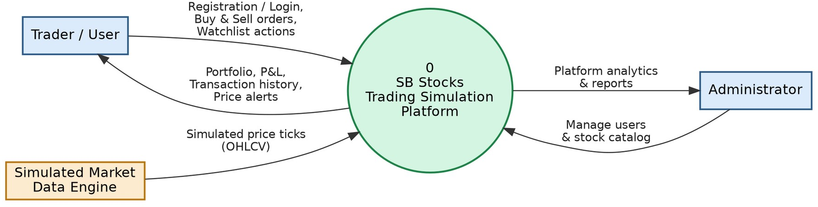

Figure 1: Level 0 Context Diagram — SB Stocks Trading Simulation Platform

Level 1 — System Processes
The Level 1 diagram decomposes the platform into its six core processes — Authentication & Security, Stock Explorer & Live Price Ticker, Portfolio & Order Execution, Transaction Ledger, Watchlist & Alerts, and Admin Management — along with the data stores they read from and write to.

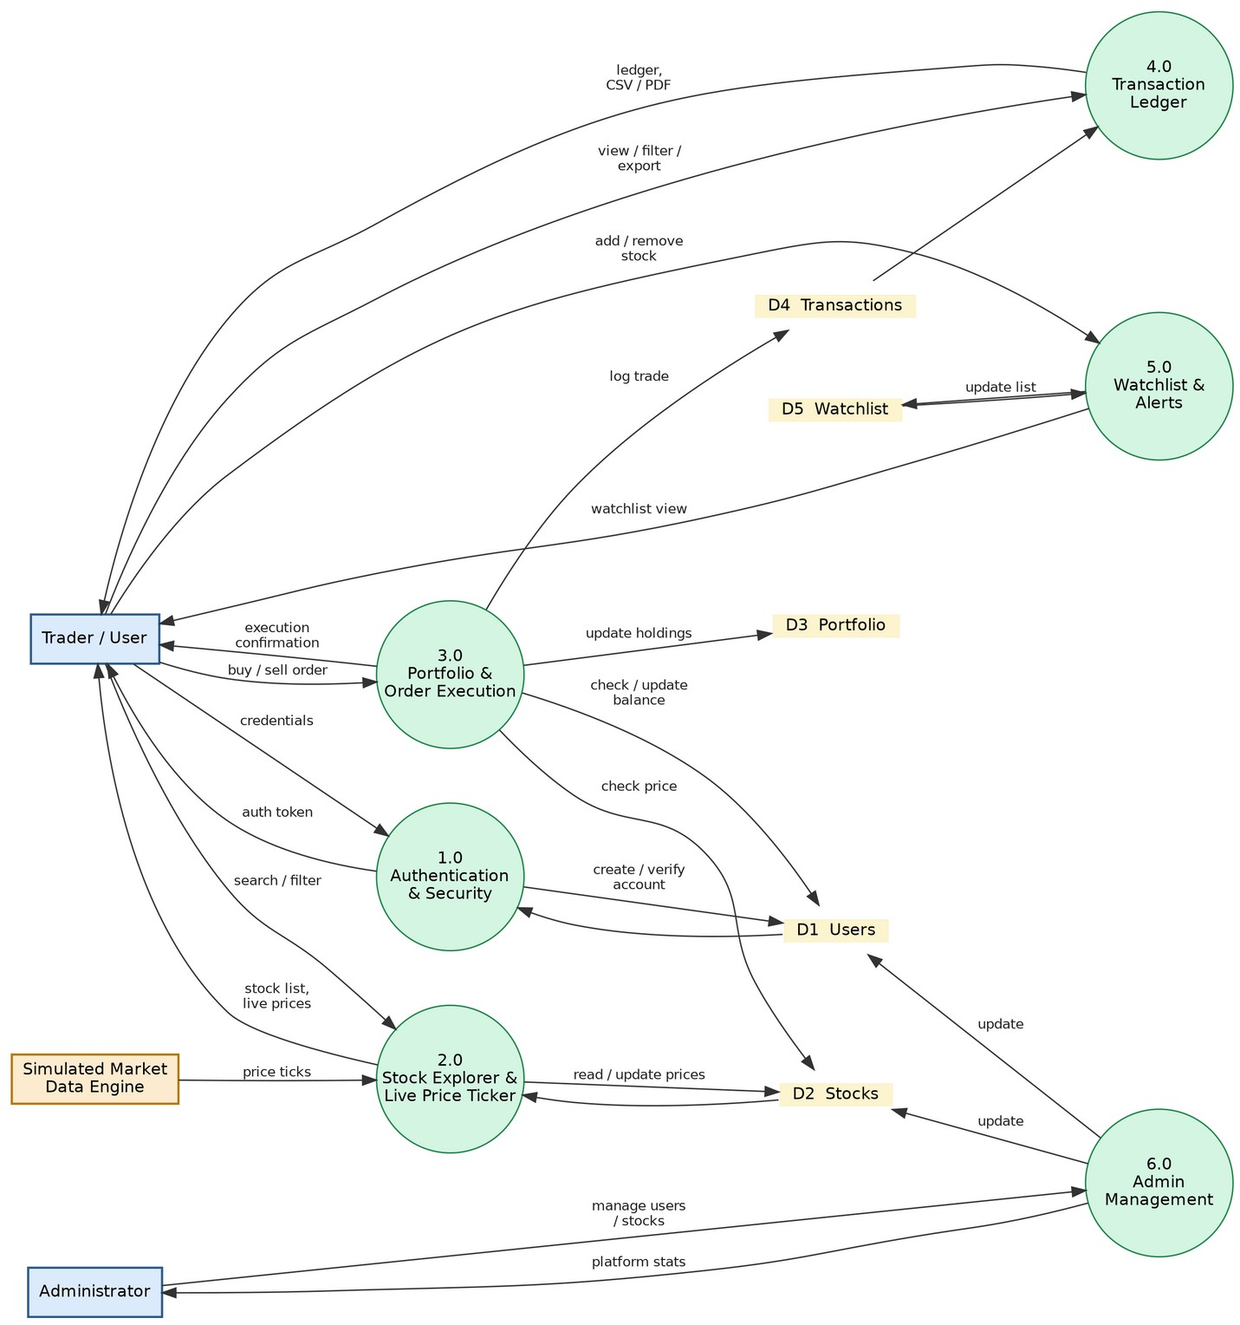

Figure 2: Level 1 DFD — SB Stocks Core Processes and Data Stores

Level 2 — Order Execution (Buy / Sell)
The Level 2 diagram zooms into Process 3.0, Portfolio & Order Execution, breaking the buy/sell workflow into order validation, trade calculation, holdings update, balance update, and transaction recording.
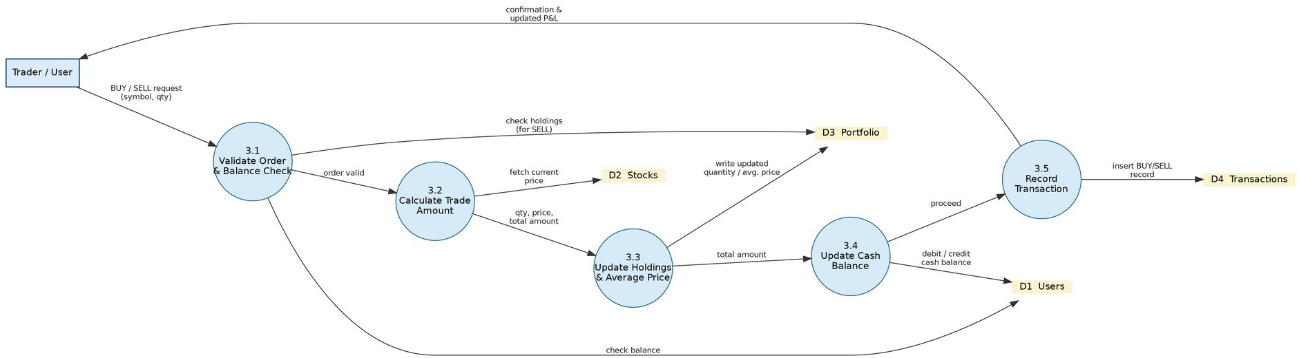
Figure 3: Level 2 DFD — Order Execution (Buy/Sell) Sub-Process

User Stories
The table below lists the user stories captured for SB Stocks, organized by user type and functional requirement (epic), along with their acceptance criteria, priority, and target release.

User Type | Functional Requirement (Epic) | USN | User Story / Task | Acceptance Criteria | Priority | Release
Trader | Registration & Authentication | USN-1 | As a new user, I can register with my name, email, and password so that I can create a trading account. | Account is created with a starting virtual balance of  $100,000 and I am | High | Sprint-1

User Type | Functional Requirement (Epic) | USN | User Story / Task | Acceptance Criteria | Priority | Release
 |  |  |  | redirected to the login page.
 |  | USN-2 | As a user, I can log in with my email and password so that I can access my dashboard. | Valid credentials generate a secure session token and route me to my dashboard. | High | Sprint-1
 |  | USN-3 | As a new user, I can use a one-click Demo Trader / Demo Admin login so that I can explore the platform without registering. | Clicking the demo button signs me in instantly using a pre-seeded demo account. | Medium | Sprint-1
 |  | USN-4 | As a user, I can log out of my account so that my session stays secure on shared devices. | Logging out invalidates my session and returns me to the login page. | Medium | Sprint-1
Trader | Dashboard | USN-5 | As a trader, I can view my cash balance and total portfolio value on my dashboard so that I know my current financial position. | Dashboard displays live balance, total holdings value, and overall profit/loss. | High | Sprint-1
 |  | USN-6 | As a trader, I can see Top Gainers/Losers and my recent trades on the dashboard so that I can quickly review market movement and my own activity. | Dashboard lists top 5 gainers/losers and the 5 most recent transactions. | Medium | Sprint-2
Trader | Stock Explorer | USN-7 | As a trader, I can search and filter the 100 listed stocks by sector so that I can find stocks relevant to my interests. | Search bar and sector tags narrow the stock list in real time. | High | Sprint-2
 |  | USN-8 | As a trader, I can sort, paginate, and switch between grid/table view of the stock list so that I can browse stocks comfortably. | Stock list supports sorting by price/change, pagination, and a grid/table toggle. | Medium | Sprint-2
 |  | USN-9 | As a trader, I can view a stock's live simulated price and interactive time-series chart so that I can analyze its trend before trading. | Stock details page renders an updating chart with open/high/low/volume data. | High | Sprint-2
Trader | Trading (Buy / Sell) | USN-10 | As a trader, I can buy shares of a stock through an order ticket that checks my balance in real time so that I never overspend my virtual cash. | Order ticket blocks submission and shows an error if the order exceeds my available balance. | High | Sprint-3
 |  | USN-11 | As a trader, I can sell shares that I own so that I can realize profit or loss on my position. | Sell orders are limited to my current holding quantity and update my balance instantly. | High | Sprint-3
 |  | USN-12 | As a trader, I receive an instant confirmation with my updated balance and portfolio after a trade so that I know the trade succeeded. | A success toast and updated dashboard figures appear within seconds of order execution. | High | Sprint-3
Trader | Portfolio Management | USN-13 | As a trader, I can view my current holdings with average price, current price, and profit/loss so that I can track my performance. | Portfolio page lists each holding with quantity, average cost, live price, and P&L percentage. | High | Sprint-3
 |  | USN-14 | As a trader, I can export my portfolio report as a PDF or CSV so that I can keep an offline record. | Export buttons generate a downloadable, correctly formatted PDF and CSV file. | Low | Sprint-4
Trader | Transaction Ledger | USN-15 | As a trader, I can view my full trade history filtered by BUY/SELL type and date so that I can audit my past trades. | Transactions page filters the ledger correctly by trade type and date range. | Medium | Sprint-3
 |  | USN-16 | As a trader, I can export my transaction history as a CSV file so that I can analyze it outside the platform. | Export produces a CSV containing all filtered transaction records. | Low | Sprint-4
Trader | Watchlist | USN-17 | As a trader, I can add or remove stocks from my watchlist so that I can track stocks I am interested in without owning them. | Watchlist updates immediately when a stock is added or removed. | Medium | Sprint-3

User Type | Functional Requirement (Epic) | USN | User Story / Task | Acceptance Criteria | Priority | Release
 |  | USN-18 | As a trader, I can quick-trade directly from my watchlist so that I can act quickly on a stock I am watching. | A quick buy/sell action from the watchlist opens the order ticket pre-filled with that stock. | Low | Sprint-4
Trader | Profile Management | USN-19 | As a trader, I can update my profile details and choose an avatar so that my account reflects my identity. | Profile changes are saved and reflected immediately across the app. | Low | Sprint-4
 |  | USN-20 | As a trader, I can change my password from my profile page so that I can keep my account secure. | Password change requires the current password and confirms success on completion. | Medium | Sprint-2
Administrato r | Admin Dashboard | USN-21 | As an administrator, I can log in to a dedicated admin dashboard so that I can monitor platform-wide statistics. | Admin dashboard shows total users, total trades, and platform activity summaries. | High | Sprint-4
 | User Management | USN-22 | As an administrator, I can view, edit, or deactivate user accounts so that I can manage the platform's user base. | Admin can search users and update or deactivate an account, with the change reflected instantly. | Medium | Sprint-4
 | Stock Management | USN-23 | As an administrator, I can add, edit, or remove stocks from the catalog through CRUD modals so that the stock listing stays accurate. | Stock CRUD modal changes are validated and immediately reflected in the Stock Explorer. | Medium | Sprint-4

